EXPERIMENT 1
A local library needs a website to streamline operations and enhance user
experience. The site will include a catalog for searching and viewing books, user
accounts for borrowing and managing books, and an admin dashboard for
managing inventory and user data. Essential features include a search function,
book details page, user login system, and contact form, The system helps both
students and library managers to keep constant track of all the books available in
the library. It allows both the admin and the student to search for the desired
book. It becomes necessary for colleges to keep a continuous check on the books
issued and returned and even calculate fines.
Librarian Admin:
- Login
- Add Book
- Update/Delete Book
- Issue Book for student
- Return Book Status
- Make Fine
- Update material ( year, semester wise )
- View material
User
- Login
- Register
- Search Book
- My Borrow History Book
- Issue Date, Exp Date
- Check Fine
- Search material ( year)

SAMPLE CODE:
<!DOCTYPE html>
<html lang="en">
<head>
<meta charset="UTF-8">
<meta name="viewport" content="width=device-width, initial-scale=1">
<title>Local Library Management System</title>
<style>
body {
font-family: Arial, sans-serif;
margin: 30px;
background: #f4f7f5;
color: #24332d;
}
h1, h2 {
color: #245b4a;
}
input, button {
padding: 10px;
margin: 5px 0;
}
button {
background: #245b4a;
color: white;
border: none;
cursor: pointer;
}
table {
width: 100%;
margin-top: 15px;
border-collapse: collapse;
background: white;
}
th, td {
border: 1px solid #ccc;
padding: 10px;
text-align: left;
}
th {
background: #e3eee8;
}
.section {
margin-top: 30px;
}
</style>
</head>
<body>
<h1>Local Library Management System</h1>
<p>Search books, borrow available books, and manage library inventory.</p>
<div class="section">
<h2>Search Books</h2>
<input id="searchBox" type="text" placeholder="Enter a book title">
<button onclick="searchBooks()">Search</button>
<button onclick="showBooks()">Show All</button>
<table>
<thead>
<tr>
<th>Book ID</th>
<th>Title</th>
<th>Author</th>
<th>Availability</th>
<th>Action</th>
</tr>
</thead>
<tbody id="bookList"></tbody>
</table>
</div>
<div class="section">
<h2>Add a Book (Librarian)</h2>
<input id="newTitle" type="text" placeholder="Book title">
<input id="newAuthor" type="text" placeholder="Author">
<button onclick="addBook()">Add Book</button>
</div>
<div class="section">
<h2>My Borrow History</h2>
<ul id="history"></ul>
</div>
<script>
// Sample library records
const books = [
{
id: 1,
title: "The Secret Garden",
author: "Frances Hodgson Burnett",
available: true
},
{
id: 2,
title: "A Brief History of Time",
author: "Stephen Hawking",
available: true
},
{
id: 3,
title: "The Midnight Library",
author: "Matt Haig",
available: false
}
];
const borrowHistory = [];
// Display all books
function showBooks(bookArray = books) {
const bookList = document.getElementById("bookList");
bookList.innerHTML = "";
bookArray.forEach(book => {
const row = document.createElement("tr");
row.innerHTML = `
<td>${book.id}</td>
<td>${book.title}</td>
<td>${book.author}</td>
<td>${book.available ? "Available" : "Issued"}</td>
<td>
${
book.available
? `<button onclick="borrowBook(${book.id})">Borrow</button>`
: "Not available"
}
</td>
`;
bookList.appendChild(row);
});
}
// Search by book title or author
function searchBooks() {
const searchText = document
.getElementById("searchBox")
.value
.toLowerCase();
const results = books.filter(book =>
book.title.toLowerCase().includes(searchText) ||
book.author.toLowerCase().includes(searchText)
);
showBooks(results);
}
// Borrow a book and set its due date
function borrowBook(bookId) {
const book = books.find(item => item.id === bookId);
if (!book || !book.available) {
alert("This book is not available.");
return;
}

book.available = false;
const issueDate = new Date();
const dueDate = new Date();
dueDate.setDate(issueDate.getDate() + 14);
borrowHistory.push({
title: book.title,
issueDate: issueDate.toLocaleDateString(),
dueDate: dueDate.toLocaleDateString()
});
showBooks();
showHistory();
alert("Book issued successfully.");
}
// Show issued books and dates
function showHistory() {
const historyList = document.getElementById("history");
historyList.innerHTML = "";
borrowHistory.forEach(record => {
const item = document.createElement("li");
item.textContent =
`${record.title} — Issued: ${record.issueDate}, ` +
`Due: ${record.dueDate}`;
historyList.appendChild(item);
});
}
// Add a new book to the catalog
function addBook() {
const title = document.getElementById("newTitle").value.trim();
const author = document.getElementById("newAuthor").value.trim();
if (!title || !author) {
alert("Please enter both the book title and author.");
return;
}
books.push({
id: books.length + 1,
title: title,
author: author,
available: true
});
document.getElementById("newTitle").value = "";
document.getElementById("newAuthor").value = "";
showBooks();
alert("Book added successfully.");
}
// Calculate a sample fine: ₹2 for each overdue day
function calculateFine(dueDate, returnDate) {
const millisecondsPerDay = 1000 * 60 * 60 * 24;
const overdueMilliseconds = returnDate - dueDate;
const overdueDays = Math.max(
0,
Math.ceil(overdueMilliseconds / millisecondsPerDay)
);
return overdueDays * 2;
}
// Display the initial catalog when the page loads
showBooks();
</script>
</body>
</html>

SAMPLE OUTPUT
STUDENT VIEW:
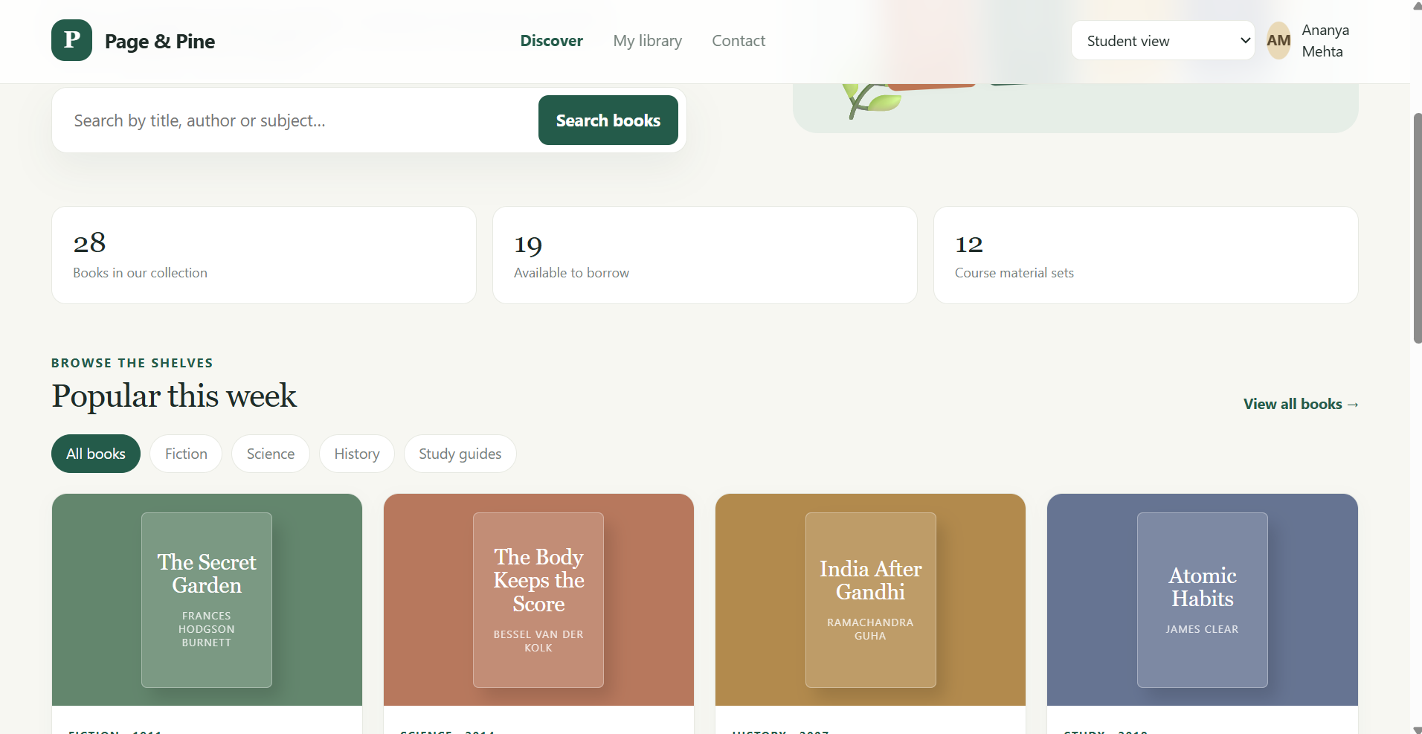
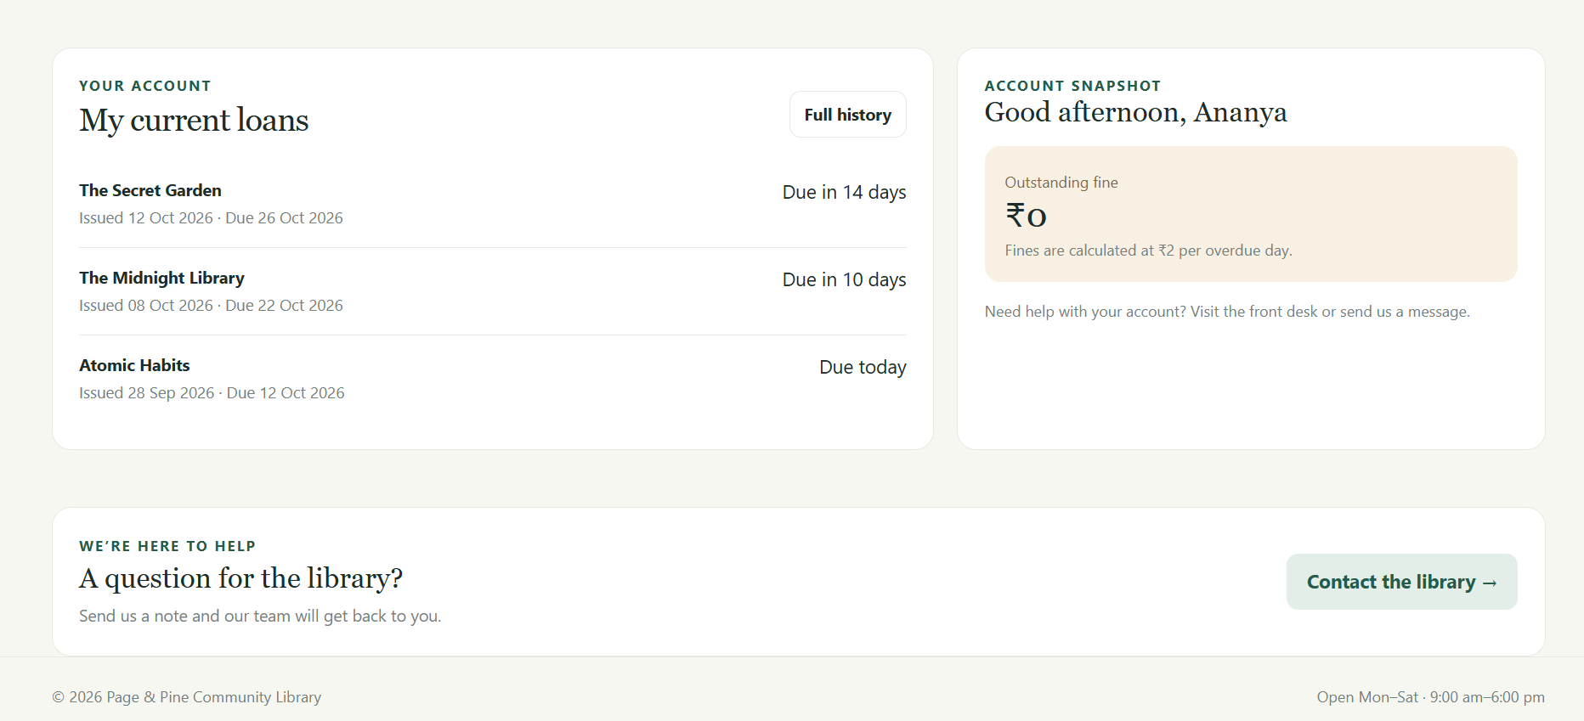
LIBRARIAN VIEW:
